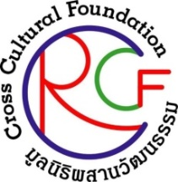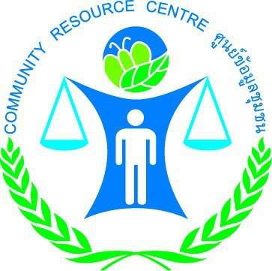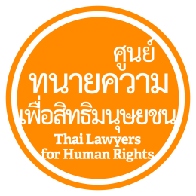
Release on 15 Aug 2016

Public Statement
Condemning Bomb Attacks in Southern Thailand, Demanding Fair Trial Rights and Transparent Investigation

During 11-14 August 2016, 17 explosions took place in seven provinces in Southern Thailand causing a number of lives and damages. Since 13 August 2016, the Thai authorities have responded by invoking Section 44 of the Constitution of the Kingdom of Thailand (Interim), B.E. 2557 (2014) to hold in custody several suspects who may allegedly be involved with the bomb and arson attacks. According to the information reported to the Thai Lawyers for Human Rights (TLHR), more than ten individuals have now been held in custody following the blasts. As of 15 August 2016, relatives and lawyers of at least four suspects have been unable to communicate with, and have been denied access to those who have been reportedly being held in military custody at the Bangkok’s 11th Military Circle.
Even though there is a compelling reason for the authorities to act promptly to bring the perpetrators to justice, the undersigned human rights organizations have found the process of identifying the perpetrators not in compliance with the rights to fair trial as provided in Articles 9 and 14 of the International Covenant on Civil and Political Rights (ICCPR). As a state party, Thailand is obliged to act in its compliance, i.e. a person can neither be subject to an arbitrary arrest nor detention, during the arrest, the individual must be informed of the reasons of the arrest and the charges promptly, and the person alleged to have committed the crime must be guaranteed basic rights including the right to have access to lawyer. In addition, the deprivation of liberty of individuals in an undisclosed place and the denial of their access to their relatives may amount to a breach to the obligations under the International Convention for the Protection of All Persons from Enforced Disappearance, which has been acceded by Thailand and the Cabinet Resolution has been made to ratify the Convention as well.
The undersigned human rights organizations have the following opinion and demand regarding the situation;
1. We condemn the perpetrators of the violence including the bomb and arson attacks in various places in the South of Thailand and would like to offer our deepest condolence to people who have been affected regardless of what is the cause that has prompted such violence.
2. We urge the law enforcement officials to use the normal justice process in their investigation to acquire evidence and to bring to justice the perpetrators without delay. All the procedures must be carried with respect to human rights principle and the trials must be conducted in a civilian court.
3. We urge the military officials to stop invoking power either from the Head of the NCPO Order No.3/2016 or Section 44 of the Constitution of the Kingdom of Thailand (Interim), B.E. 2557 (2014) and to disclose the places where all the individuals have been deprived of liberty. The suspects must also be allowed to have visits by their families and access to their lawyers in private meetings.

With respect in the rights and freedoms of the people

Thai Lawyers for Human Rights (TLHR)
Cross Cultural Foundation (CrCF)
Community Resources Centre Foundation (CRC)
Human Rights Lawyers Association (HRLA)
Union for Civil Liberty (UCL)
ENLAWTHAI Foundation (EnLAW)

